NAME: MEERAB AMIR

STD ID: FA17-BECE-0017

Lab 08

EXERCISE 1:

x=input("Enter num:")

if (x<50)

disp("Number is lesser")

elseif (x==50)

disp("Number is equal")

else

disp("Number is greater")

end

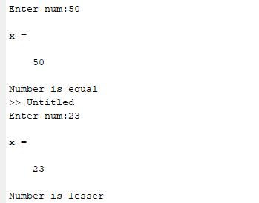

EXERCISE 2:

x=input("Enter num1:")

if (x<5)

y=2\*x+1

else

y=2\*x

end

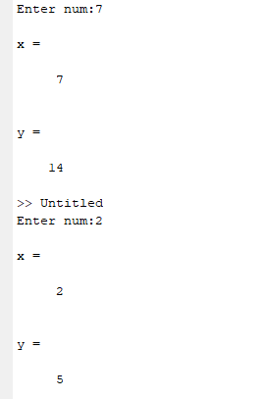

EXERCISE 3:

a=input("Enter num:")

b=input("Enter num:")

c=input("Enter num:")

if ((a>b) & (a>c))

fprintf("%d is greater",a)

elseif ((b>a) & (b>c))

fprintf("%d is greater",b)

else

fprintf("%d is greater",c)

end

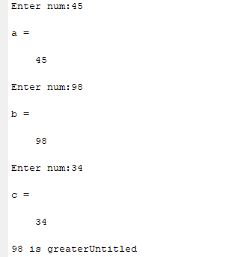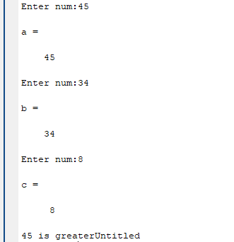

EXERCISE 4:

num=input("Enter num:")

for x=1:num

x=x^2;

disp(x)

end

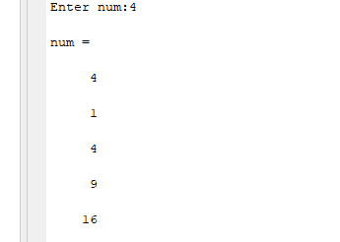

EXERCISE 5:

n=10

a=1

fact=1

while (a<=10)

fact=fact\*a

a=a+1

end

disp(fact)

